**Assessment 1 – Java EE**

**Nicholas Randles – B00058026**



**Business Scenario**

A shop owner has come to me the developer as they want to make their store ‘Access Apparel’ available online. The website should allow customers to see all of the prouducts they are selling. They want the home page to show all the major brands they sell which will lead to a categories page when they click on one. They then want the customer to be able to add an item to their cart. They want the customer to be able to update their cart and proceed to checkout. They then want the user to be able enter details and checkout.

**Entity Relationship Diagram**

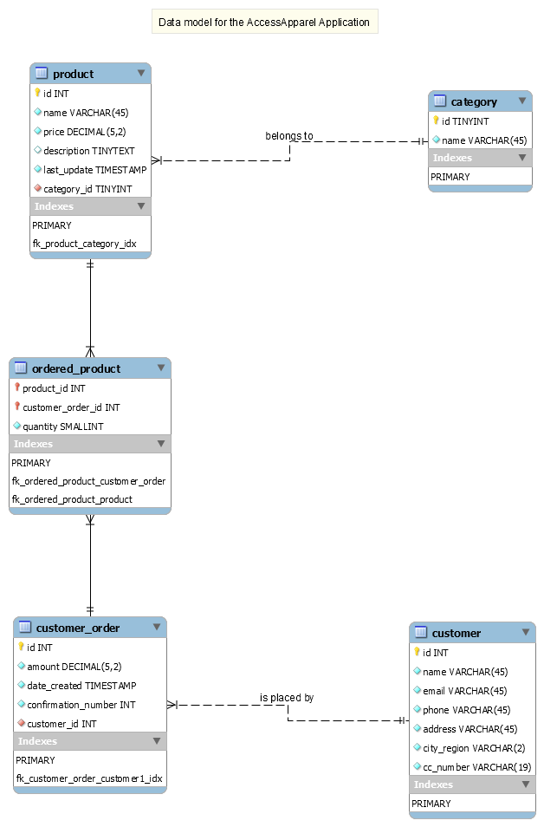

**Interaction Diagram**

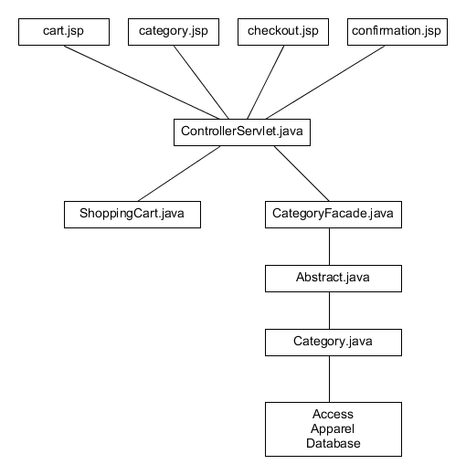

**Business Logic mapped to Message and Session beans**

Enterpise JavaBeans help us implement business logic in a more efficient way. We use session beans and entity bean to help us to do this. We use session beans to handle the client’s data and we use entity beans to handle the database.

A session bean serves one client at a time. The two types of session beans we use are Stateless and Stateful. A stateless session bean does not store the client’s information between invocations. The only state it may contain is not unique to the client, for example, a database connection or another Enterprise JavaBean. A stateful session bean contains information relating to the interaction between the bean a particular client across methods and transactions.

An entity bean consists of data such as columns and rows in a database. They provide us with methods for writing and reading to that data.

**User Interface screenshots**

**Index page**

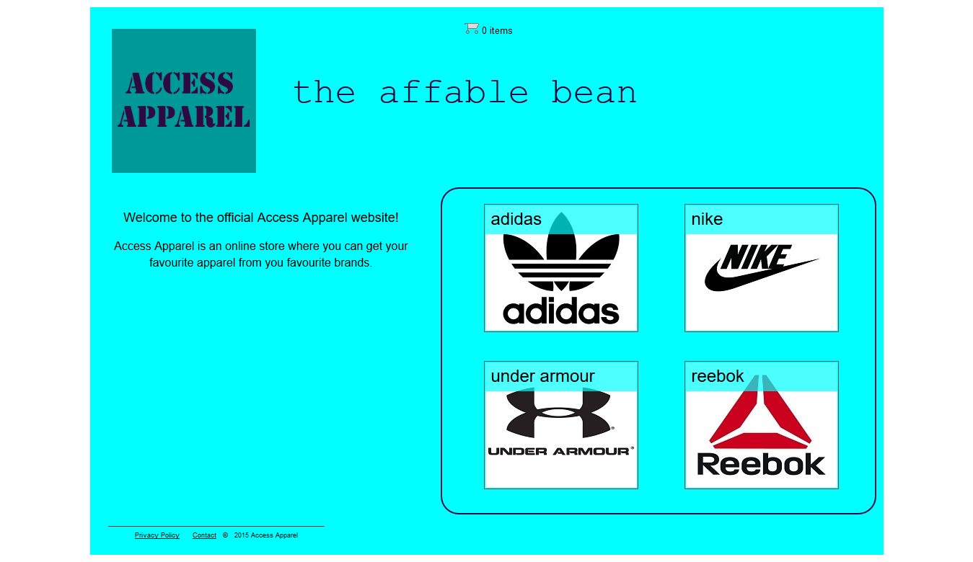

**Category page**

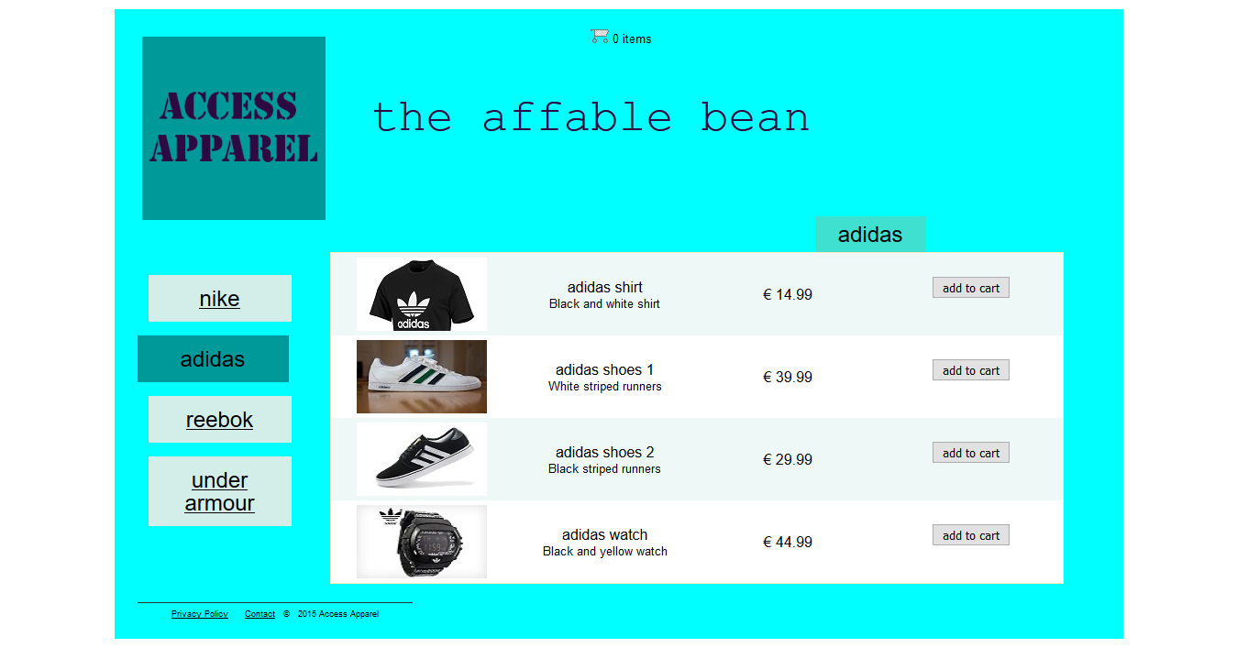

**Page when item add to cart**



**Cart page**

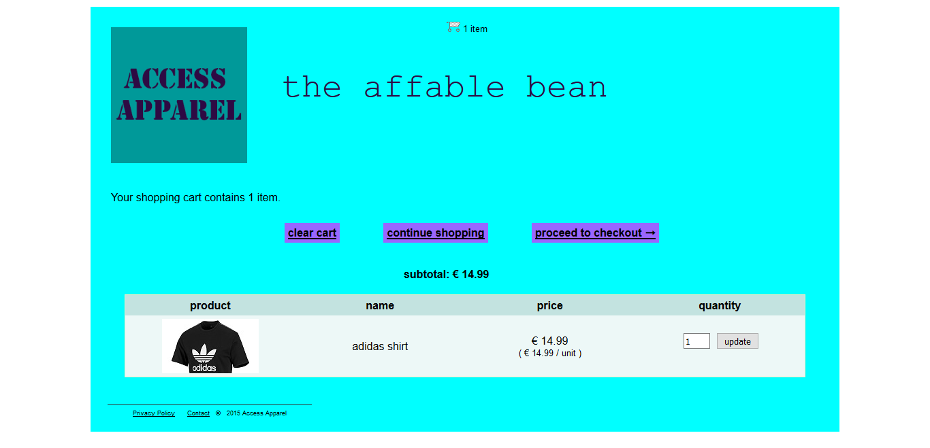

**Checkout page**

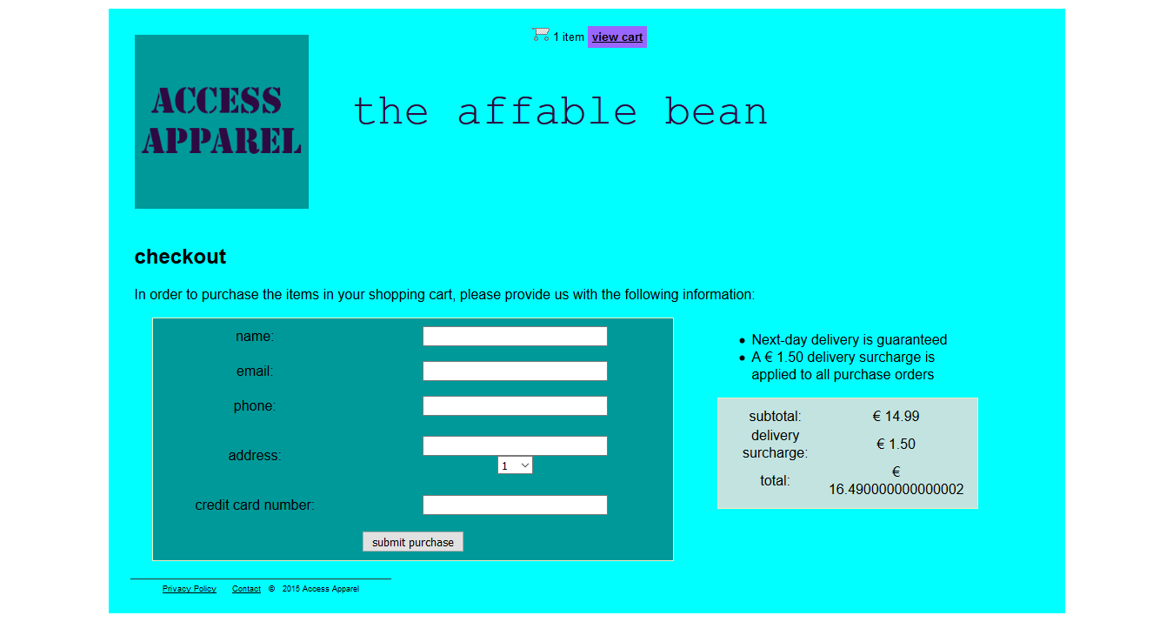

**Conclusion**

Overall I learned a lot about Java EE from doing this assessments. I learned about the advantage of creating a web application this way over traditional methods. I learned things such as how to create Java server pages and java server page fragments and link them through a deployment descriptor. I learned how to create a database and link it through a connection pool. I learned how to implement business logic through entity and session beans.